http://lifehacker.com/5867049/nine-stubborn-brain-myths-that-just-wont-die-debunked-by-science

Nine Stubborn Brain Myths That Just Won't Die, Debunked by Science
Adam Dachis
Filed to: BRAIN HACKS12/12/11 8:00am
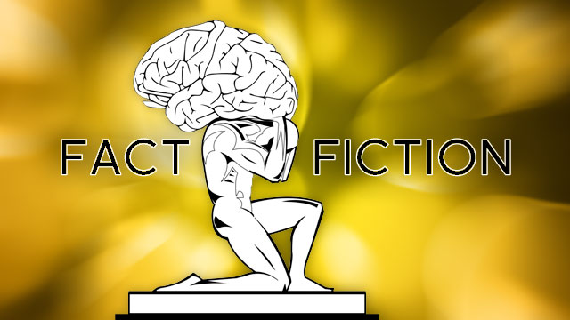
Brain games will make you smarter! The internet is making you dumber! Alcohol is killing your brain cells! The brain is a mystery we've been trying to solve for ages, and the desire to unlock its secrets has led to vast amounts of misinformation. Many of these false notions are more widely believed than the truth. We took our healthy skepticism and a bunch of brain research to find the truth behind some of the most common myths about intelligence and our brains. Here's what we learned.
Photo by Igor Nazarenko (Shutterstock).

Myth 1: Left-Brained People Are Organized, Right-Brained People Are Creative
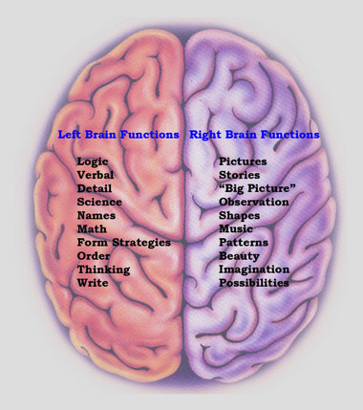
We're a stubborn people who become set in our ways, so it's no wonder we want to believe that our inclination towards creativity or organized thinking is decided at birth. The right- or left-brained myth suggests we're simply fulfilling a version of our genetic destiny and we should accept our strengths and weaknesses as part of who we are. But as Lisa Collier Cool points out in her article for Yahoo Health, we're not really right- or left-brained at all:
This myth began in the 1800s, where doctors discovered that injury to one side of the brain frequently caused loss of specific abilities. Brain scan experiments, however, show that the two halves of the brain are much more intricately linked than was originally thought, so problem-solving or creative tasks fire up activity in regions of both hemispheres of the brain, not just half. It is true that the right side of the brain controls the left side of the body and vice versa, so a right-brain injury can cause disability on the left side of the body.
More recently this myth has been used as an attempt to explain creativity,dyslexia, and even homosexuality in left-handed people, but the origin of the southpaw is still a mystery. Whether or not there is a compelling link between right- or left-handedness and specific common traits remains to be seen, but rest-assured that being more creative or more organized doesn't inhibit you from having a talent for both.

Myth 2: Your Memory Is An Exact Account of What You See and Experience
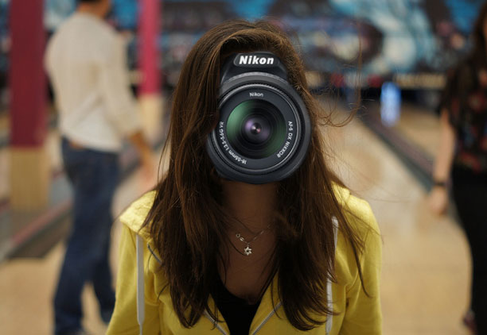
Some of us have better memories than others, but no memory is perfect. If you need proof, close your eyes and try to imagine the face of someone you know. In fact, try to imagine your own face. While you'll be able to conjure up a decent idea of the way you or anyone else looks, you won't be able to envision every last detail. This is because our memories don't recall anything we see, hear, sell, taste, or touch with much detail at all. Instead, as psychologist Dan Gilbert points out in his book Stumbling On Happiness, our brains record the seemingly necessary details and fill in the rest when it's time to remember:
[T]he elaborate tapestry of our experience is not stored in memory-at least not in its entirety. Rather, it is compressed for storage by ﬁrst being reduced to a few critical threads, such as a summary phrase ("Dinner was disappointing") or a small set of key features (tough steak, corked wine, snotty waiter). Later, when we want to remember our experience, our brains quickly reweave the tapestry by fabricating-not by actually retrieving-the bulk of the information that we experience as a memory. This fabrication happens so quickly and effortlessly that we have the illusion (as a good magician's audience always does) that the entire thing was in our heads the entire time.
Gilbert's conclusions come from memory researcher Daniel Schacter, who believes the construction of memory is very similar to the way we imagine the future:
We have argued in recently that memory plays a critical role in allowing individuals to imagine or simulate events that might occur in their personal futures. We have further suggested that understanding memory's role in future event simulation may be important for understanding the constructive nature of memory, because the former requires a system that allows flexible recombination of elements of past experience, which may also contribute to memory errors.
While a little common sense and life experience can demonstrate the imperfections in your (and everyone else's) memory, Schacter's research points to two important things: we're no good at recalling past events or imagining the future because our process for doing either is essentially the same—at least as far as our brain functionality is concerned. While this points to much more of a problem than a solution, it certainly helps to remember that no memory is perfect and we're all designed to recall with error. Next time someone gets something wrong, it's at least worth remembering that.

Myth 3: You Only Use 10% of Your Brain
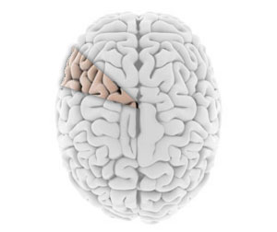
As with many myths, you can generally begin the debunking process by reminding yourself that the claim is pretty ridiculous. If we only used 10% of our brains, what's the point of the other 90%? According to myth-busting site Snopes, it was television that made us dumber:
In 1998, national magazine ads for U.S. Satellite Broadcasting showed a drawing of a brain. Under it was the caption, "You only use 11 percent of its potential." Well, they're a little closer than the ten-percent figure, but still off by about 89 percent. In July 1998, ABC television ran promotional spots for The Secret Lives of Men, one of their offerings for the fall season's lineup. The spot featured a full-screen blurb that read, "Men only use ten percent of their brains."
After that, champions of the paranormal used the 10% claim to explain the potential for psychic powers. It became fun to imagine the incredible potential available to us humans once we were able to unlock the remaining 90%. Unfortunately for superpower fans everywhere, we're already enjoying most of what our brains can currently offer. Lisa Collier Cool explains:
Brain imaging studies using PET scans and functional MRI show that any mentally complex activity uses many areas of the brain, and over a day, just about all of the brain gets a workout. More proof that the entire brain is crucial for daily life is the devastating impact of damage to even a small area of the brain. However, we do have some brain reserves. An autopsy study found that seniors who stay mentally active-through activities like reading the paper, going to the theater, or playing chess-are less likely to develop Alzheimer's disease-even if they have the characteristic physical brain changes typical of dementia, suggesting that mental function has a "use it or lose it" component. That allows people who keep their brain stimulated to develop more brain reserves, allowing them to continue functioning normally even as their brains are being damaged by Alzheimer's.
While you can't look forward to developing incredible superpowers with the help of rapid evolution, or any other crazy theory, you can keep yourself healthier later in life by simply staying mentally active. You may not be able to bend metal with your mind, but at least you'll stay coherent in your golden years.

Myth 4: Alcohol Kills Brain Cells
Just as we noted when debunking the myth that you only use 10% of your brain, a little bit of brain damage goes a long way. If you were actively killing brain cells when consuming alcohol, you'd notice some permanent side effects pretty quickly. Although alcohol does have a significant effect on your brain and body, brain damage isn't a given. You'll have to drink yourself into a coma to go that far.

What Alcohol Actually Does to Your Brain and Body
Alcohol, like caffeine, has an enormous reputation but loose understanding in popular culture.…Read more
The proof comes from a 1993 study by Grethe Jensen that matched brain samples from both (deceased) alcoholics and non-alcoholics and found no difference in the density of brain cells. (You can read more about this studyhere.) What alcohol actually does in inhibit the functionality of brain cells, and former Lifehacker writer Kevin Purdy explained it best:
What alcohol can and does do to your brain is affect the way yourneurons get their firing triggers from glutamate. It infiltrates the glutamate receptors in your synapses, hurting their ability to send off their normal "fire" messages. Alcohol has this impact all across your brain—the parts that control muscles, speech, coordination, judgment, and so on. Keep that in mind the next time you or someone else claims that they drive, golf, or otherwise perform some task better with alcohol's help.
In the end, you just need to worry more about your choices than the lifespan of your brain.
Kevin Purdy
Filed to: EXPLAINERS11/09/10 9:00am
Alcohol, like caffeine, has an enormous reputation but loose understanding in popular culture. Learn how it's absorbed and how fast, why it's essential to reality TV altercations, its paradoxical sexual effects, and its life-lengthening potential, whether red wine or Bud Light.

What Caffeine Actually Does to Your Brain
For all of its wild popularity, caffeine is one seriously misunderstood substance. It's not a…Read more
Image via TheDeliciousLife.
Everyone, it seems, takes their cues on how alcohol affects the mind and body from an eclectic mix of knowledge: personal experience, pop culture, tall tales of long nights, the latest studies to make the health news wires, and second-hand tips. You might have gathered that alcohol is a depressant, that it's dehydrating, that you can drink about one drink an hour and stay relatively sober. Some of that is true. But much of it depends on a large number of factors.
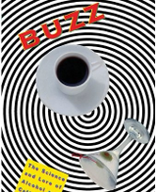
Let's dig into some of the things we do and don't know about alcohol. Relevant sources are linked where cited, but much of the background material comes from Buzz: The Science and Lore of Alcohol and Caffeine (new-ish Kindle edition linked there). It's a science-based tome written in a clear language by Stephen Braun, and was the main reference for our take on caffeine.
We're taking a few things for granted here: that you understand some of the basics of alcohol consumption, blood alcohol content, legal limits, what it feels like when you've had too much to drink, and the serious illness of alcoholism. We're not trying to help you get loaded quicker, or drink more for longer periods. We're digging into some of the science behind how you and alcohol interact.

It Works Differently on Full Stomachs, Young Women, Some Asians, and Aspirin Takers
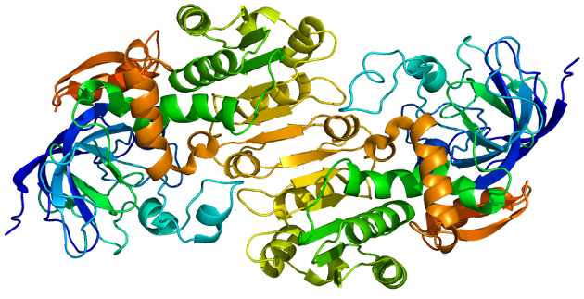
Your body sees alcohol as a poison, or at least as something it doesn't actually want inside it. To fight back, and sober you up, humans produce an enzyme called alcohol dehydrogenase.
That enzyme gets its shot at your alcohol when it attempts to pass through the stomach lining, and when it reaches your liver, primarily. On contact, it snatches a hydrogen atom off the ethanol molecules in your drink, rendering it into non-intoxicating acetaldehyde. Humans can then use aldehyde dehydrogenase as a kind of clean-up crew, breaking down the acetaldehyde that's sometimes considered a cause of hangovers, along with dehydration. (For more on the myths versus reality of hangovers, see our guide to hangover cures). Image via Wikimedia Commons.
Hangover Cures: Myth, Legend, and Fact
Hangovers rank right up there with drunk dialing your angry ex as one of the least pleasant…Read more
Seems pretty simple, no? It's a fight between how much you can drink, versus how fast your enzymes can bust down your indulgences and their byproducts. But many factors affect certain people's production of the two alcohol-crushing compounds:
• Alcohol dehydrogenase (AD) is, for reasons not wholly understood, more effective in men than in women. Young men, in fact, may have up to 70 to 80 percent greater enzyme activity in the presence of alcohol. But men's AD effectiveness also drops off with age at a faster rate than in women, such that, by around 55 or 60, men may find themselves able to handle less alcohol than their female counterparts, all other factors being equal.
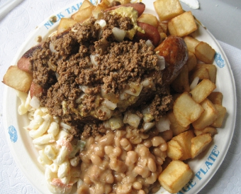
• A full stomach helps break down alcohol, but not because your food "soaks up" the alcohol. When you eat a big meal, your stomach's pyloric sphincter, a kind of release valve into the small intestine, closes tightly. Your body knows that you've got food that should get a good going-over in your stomach before it heads straight to the high-absorption small intestine, so it keeps it there, and the AD in your stomach has more time to work on the alcohol. Drink on an empty stomach, and the liquid quickly makes it into the small intestine, where there's more than 200 square meters of surface area for absorption into your body. Image via peretzpup.
• Another big factor in alcohol absorption, and alcohol's effects, is genetics. Your great-great-grandparents have a say in how buzzed your Friday night gets, for sure, but for roughly one-third to half of Asian drinkers, it's more than a slight variance. Alcohol flush reaction, a flushing of the face when drinking, occurs because the enzyme "clean-up crew," aldehyde dehydrogenase, is mutated by just one amino acid. That changes how effective its molecules are in bonding with, and busting up, acetaldehyde. With excess acetaldehyde in their system, those with a flush reaction get red-faced, and can experience heart palpitations, dizziness, and severe nausea in extreme cases. Your own genetic makeup of AD and aldehyde dehydrogenase affect your ability to break down alcohol and its byproducts in similar fashion.
• Don't take aspirin before drinking, unless you love hangovers. Aspirinseriously cuts the effectiveness of your body's AD enzymes. In one 1990 study, the average blood alcohol levels of those who took two maximum strength aspirin tablets before drinking were an average of 26 percent higher than those who were aspirin-free. Other studies have suggested even more impact on your body's ability to break down alcohol. That also means more acetaldehyde in your system down the line, so you'll learn your lesson quickly if you're considering aspirin as a "helper."

Side Note: Absorption and Elimination Is a Curve, Not a Straight Line
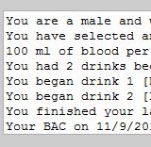
Think you've got a handle on the basic one-drink-per-hour algorithm for your weekend nights? Check out this explainer from a forensic toxicology lab, which also links up an advanced Blood Alcohol Calculator. Your BAC moves through plateaus, responds differently to drinks higher than 20-25 percent alcohol by volume, and eliminates some alcohol in pure form—which is how police can measure it on your breath.

It Extends Your Life—Kind Of
Every few weeks, it seems, a new study suggests a glass of wine, or sometimes any old drink, lengthens your life if you don't overdo it. Plucking just one out of the pile, you'll see that in Alcoholism: Clinical and Experimental Research, researchers followed 1824 people over a total of 20 years, as they aged between 55 and 65. Of those who abstained entirely, 69 percent died. Among those who drank in "moderate" amounts, 41 percent died—which was 23 percent less than the "light" drinkers. Even "heavy drinkers" fared better than abstainers, with just 61 percent passing away during the study period.
How could a substance that everybody and their five brothers tell you to go easy on extend your life? Popular theories center on the antioxidants andresveratrol compounds found in wines, or on the studies showing alcohol as increasing levels of HDL ("good") cholesterol.
But Jonah Lehrer at Wired points out the not-so-obvious: the link between a longer life and alcohol may not be direct, but it's likely very real. It relates to the long-term benefits of reducing stress, as well as alcohol's role in facilitating get-togethers and acting as a "social lubricant":
What does this have to do with longevity? In recent years, sociologists and epidemiologists have begun studying the long-term effects (Direct PDF link) of loneliness. It turns out to be really dangerous. We are social primates, and when we're cut off from the social network, we are more likely to die from just about everything (but especially heart disease). At this point, the link between abstinence and social isolation is merely hypothetical. But given the extensive history of group drinking—it's what we do when we come together—it seems likely that drinking in moderation makes it easier for us develop and nurture relationships. And it's these relationships that help keep us alive.
Image via LINXBAS.
Theoretically, then, you might get some of the same benefits if you were a savvy, social Diet Coke drinker. But it's likely a combination of actual alcohol effects, along with their social expressions, that leads to study after study showing drinkers as getting some kind of life-extending benefit.

It Doesn't "Kill" Brain Cells, but Does Inhibit Them
It's true that at high concentrations, like the nearly 100-percent pure alcohol used in sterilizing solutions, alcohol can indeed kill cells and neurons (and nearly anything else). But given that the blood reaching your brain is only at 0.08 percent alcohol if you're legally intoxicated, or, say, 0.25 percent if you've just closed a major deal in Tokyo, it's not doing a lot of damage to your actual brain cells (liver cells and other organs, with long-term chronic abuse, are another matter).
Don't believe it? A major study by Grethe Jensen and colleagues in 1993 matched brain samples taken from both alcoholics and nonalcoholics, from groups of the two dead from non-alcohol-related causes. There were no significant differences found in either the number or density of brain cells between the groups. Misconception Junction tackles Jensen's study and the topic in more depth.
What alcohol can and does do to your brain is affect the way your neurons get their firing triggers from glutamate. It infiltrates the glutamate receptors in your synapses, hurting their ability to send off their normal "fire" messages. Alcohol has this impact all across your brain—the parts that control muscles, speech, coordination, judgment, and so on. Keep that in mind the next time you or someone else claims that they drive, golf, or otherwise perform some task better with alcohol's help. As Stephen Braun puts it in Buzz: The Science and Lore of Alcohol and Caffeine:
Substances such as cocaine and LSD work like pharmacological scalpels, altering the functioning of only one or a handful of brain circuits. Alcohol is more like a pharmacological hand grenade. It affects practically everything around it.

Side Note: That's Also Why It, Uh, "Inhibits" Sex
The studies and implications are numerous, to say the least, but if you want a thumbnail understanding of how alcohol, as Shakespeare put it, "provokes the desire, but ... takes away the performance," it has to do with the firing of nerves, in the brain and elsewhere, that would relax the arteries enough to get both parties moving. It's a bit more complex than that, and drinking in moderation can be a net benefit in some cases, but alcohol, paradoxically, doesn't help one specific region of your self to "relax."

Side Note 2: Alcohol is Particularly Effective at Inhibiting Memories
Like the sexual response, the way the brain makes memories is far from comprehensively understood. But it does seem linked to N-Methyl-D-aspartic acid, or NMDA, the receptor for which alcohol seems particularly adept at interfering with, according to Braun. Studies have shown that while subjects under alcohol's influence can recall existing memories, events happening during inebriation are regularly hard to remember. It varies with the amount consumed, and seems to top out at a serious 0.2 percent blood alcohol content, but anything from flimsy recall to full-on blackouts are possible due to alcohol's unique bond with the stuff that should make memories.

It Makes Other People Seem More "Intentional"
If you'd never been raised to think things through, you'd assume that most actions people took were fairly intentional, and possibly pointed at causing you harm. The same holds when people are asked to make snap judgments about things happening. But give yourself any amount of time, and you'll generally think out all the reasons something could have happened, avoiding your natural intentionality bias and preventing heated arguments with otherwise close friends, bar altercations, and 80 percent of all reality show plots. Image via terren in Virginia.
But, as you might have guessed, that reasoned thinking gets lost when there's a night's worth of alcohol moving through your brain. In the Personality and Social Psychology Bulletin, researchers detail a study with 92 men, made to go three hours without food, then given a shot of either juice, or juice with more than a shot of pure alcohol. All the glasses were rimmed with alcohol to mask the placebos. The men thought they took part in a taste test, then did unrelated tasks for 30 minutes.
After that, they were asked to determine whether a series of deliberate, accidental, or vague stated actions ("He deleted the email," "She looked for her keys," "She tripped on the jump rope," etc.) were deliberate or accidental.Ars Technica sums up the results:
Nearly all the participants, no matter what condition, judged all the unambiguous statements correctly. However, when the actions were ambiguous and could have been performed either intentionally or unintentionally, the "drunk" participants were much more likely to perceive the actions as deliberate than the sober participants were.
The study showed that it didn't much matter whether a man thought he was drunk; the jump to conclusions about an intention only took place when someone actually did have too much in them.

It's a Terrible Sleep Aid
Ever heard the term "nightcap?" People have long believed that alcohol helps you get to sleep—and that part can be true, for some. Once you're asleep, though, alcohol's interaction with your brain can lead to some fitful sleep—and no sleep at all, especially if you consumed caffeine anytime close to hitting the pillow. Image via Ella's Dad.
Just as with caffeine, your brain proves remarkably adept at adapting itself and responding to the ethanol molecules jamming up its receptors and interfering with neuron firings. It takes a bit for the brain to catch up, though, and when your brain starts kicking in and reclaiming all its nooks and crannies, it can wreak havoc on your crucial REM sleep, along with your more passive, general resting. If you've had caffeine, too, it's a drug that can take up to 5 hours to break down half a dose. If it's in your system at the same time as your brain is trying to compensate for alcohol, the combined "revenge" of both drugs can lead to some fairly restless sleep, according to Braun's Buzz.

Myth 5: The Internet Is Making Us Dumber
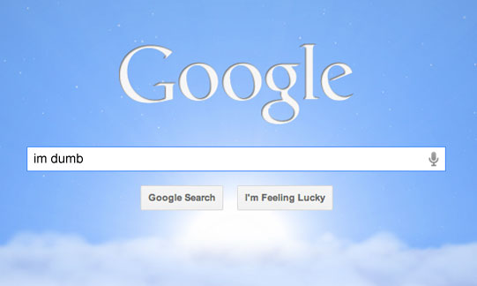
If you're familiar with the term "sweeping generalizations," this myth is one of them. Any claim that takes on a large entity and attempts to boil it down to a single, simplistic conclusions is bound to be wrong. This is how we end up with stereotypes. Claiming that the internet is making us dumber could have the glimmer of truth under specific circumstances, but so far no research points to any significant dumbing down of the sort.
The reason we find it easy to believe the internet is making us dumber is because, in some ways, it's making us less self-reliant. Our GPS devices navigate for us and we neglect to remember things because we have Google search. That doesn't make us dumber, necessarily, but rather causes us to rely more on what psychologist Daniel Wagner calls transactive memory. This type of memory is actually very useful because it allows us to, in essence, store more data in less space. Instead of remembering the contents of an entire article, we can simple remember the name or a few key words that we can entire into a search engine to pull it up.

How to Re-program Your Memory to Become More Self-Reliant
Modern conveniences like smartphones and the internet provide us with access to more information…Read more
This comes with the obvious downside of lacking the full recall for actual information in your brain, which is why many people feel the internet is turning us into idiots. When our access is cut off, suddenly we're bereft of our knowledge because our transactive memories are rendered useless. The reality is, without actual proof that the internet is making us dumber, so far it appears that the entire idea hinges on the evolving manner in which we interact with and access information as opposed to any sort of fact, making this more of a cultural claim than a scientific one.

Myth 6: Listening to Classical Music Turns Babies into Geniuses
This myth began with a study conducted by Dr. Gordon Shaw and Dr. Frances Rauscher at UC Irvine in the early 90s. Preliminary results suggested that a specific piece of music composed by Wolfgang Amadeus Mozart boosted the spatial-temporal reasoning skills in young children. This made for big headlines and the creation of entire businesses surrounding the sale of Mozart-based products to mothers who wanted their children to become geniuses with the press of a play button. According to Brian Dunning of the podcast Skeptoid, the final results weren't quite so miraculous. He said, "although they had some promising preliminary results from a particular Mozart piece which made immediate worldwide headlines, the full study eventually showed no significant result." Likewise, in an in depth analysis on the Mozart Effect, Donna Lerch and Thomas Anderson concluded:
The music of Wolfgang Amadeus Mozart is both physically and aesthetically accessible to the general public. A number of studies have indicated that listening to Mozart's work may temporarily increase cognitive skills. Other studies have found no statistically significant "Mozart effect". It is unfortunate that the media and commercial ventures have taken the initial modest, unverified study and conjured up a pseudo-science which gave rise to, and which continues to promote, a full-blown industry.
Despite the readily available truth, the preliminary findings of this initial study were blown so far out of proportion that Mozart brain boost is one of the more stubborn myths still alive in our culture. If you like classical music, there's likely no harm in playing it for your child so long as you don't expect it to do any of the hard work for you.

Myth 7: Brain Games Make You Smarter
Wouldn't it be nice if we could actually boost our brain power by playing a few games on the bus ride to work? That's the promise the popular Nintendo DS title Brain Age made, starting a brain games trend that rages on. The BBC commissioned a commissioned a study to test these claims and found that they didn't really make a difference:
More than 8,600 people aged 18 to 60 were asked to play online brain games designed by the researchers to improve their memory, reasoning and other skills for at least 10 minutes a day, three times a week. They were compared to more than 2,700 people who didn't play any brain games, but spent a similar amount of time surfing the Internet and answering general knowledge questions. Researchers said the people who did the brain training didn't do any better on the test after six weeks than people who had simply been on the Internet. On some sections of the test, the people who surfed the Net scored higher than those playing the games.
That isn't to say that practicing simple math—one of the games included in Brain Age—won't do you some good. We use simple math on a daily basis, after all. That said, look at any brain games you play as specific practice. You'll get better at that game, but don't expect any boost in your general intelligence.

Myth 8: Your IQ Is Fixed and Stays the Same Throughout Your Life
Your IQ, or intelligence quotient, is a score that's supposed to quantify your level of intelligence. What defines intelligence is still up for debate, so a high IQ isn't necessarily an accurate measurement, but it has long been assumed that our scores don't change—we're stuck at the level of intelligence we were born with. As you may have guessed, that's not true. Business Insider points to a few studies that show changes in IQ after just a few weeks of effort:
There's a lot of research supporting this theory. In one, "33 British students were given IQ tests and brain scans at ages 12 to 16 and again about four years later by researchers at the Wellcome Trust Centre for Neuroimaging at University College London; 9% of the students showed a significant change of 15 points or more in IQ scores," reports the Journal. And these changes weren't just due to measuring errors. The MRIs showed changes in gray matter - which are linked to IQ - says one of the study's co-authors, Cathy Price.
This is good news, because it seems that having a higher IQ is a good thing. People with a lower IQ (meaning in the 75 to 90 range) are more likely to wind up in prison, in poverty, or drop out of high school. A study conducted at the University of Delaware asserts that a higher IQ also has a correlation with higher social intelligence. Since IQ can change, these studies may not relate so much to people with higher scores but rather hardworking, studious individuals. Either way, there seems to be no harm in boosting your score and nothing barring you from doing so.

Myth 9: Your Brain Works Better Under Pressure
At some point in your life, you may have experienced a moment where you had an impossible deadline and somehow managed to finish your work—perhaps even exceptionally well. When the pressure is on, sometimes we find it in ourselves to pull through. Although a ticking clock can be an excellent motivator, as the looming consequences of missing a deadline can certainly get you working fast, it doesn't result in better brain performance. In fact, according to the Franklin Institute, pretty much any kind of stress makes it harder for your brain to function:
As science gains greater insight into the consequences of stress on the brain, the picture that emerges is not a pretty one. A chronic overreaction to stress overloads the brain with powerful hormones that are intended only for short-term duty in emergency situations. Their cumulative effect damages and kills brain cells.
In the end, if you believe you work better under pressure it's simply because the end result seems to justify that belief. Stress isn't enabling you to work better, but simply providing the motivation to get you to work in the first place. You'll be doing yourself a favor if you find a better way to get your work done before the clock starts ticking, but if you get stuck in a pinch at least there are a number of ways to keep the stress you're feeling to a minimum.

What Stress Actually Does to You and What You Can Do About It
Stress is an unpleasant fact of life. We all experience it for various reasons, and we all try to…
Stress is an unpleasant fact of life. We all experience it for various reasons, and we all try to come up with ways of coping with it—some with more success than others. So what exactly is stress doing to your mind (and body) when you're staring down a deadline? And what can you do to power through it?
The real problem with stress is that, for such a well understood and universally experienced condition, as a society we deal with it so poorly that it leads to many of our most lethal illnesses and long-term health problems. High blood pressure, heart disease, cancer, stroke, obesity, and insomnia are all medical conditions across the spectrum that can be related to or directly influenced by high stress as an environmental condition.
In order to cut through some of that fog, let's take a brief look at what stress is, how it impacts us on a physical and mental level, and finally what we can do about it, with the help of some experts. Photo by bottled_void.

Defining Stress: Acute and Chronic
Everyone experiences stress in some way, shape, or form. We all recognize when we're in stressful situations, and we all know when we're stressed. At the same time, stress is more than just a feeling that we have a lot to deal with. For the purposes of our explainer, we're focusing on so-called "bad stress," as opposed to "good stress," like the kind of you experience on a roller coaster (if you went on willingly), when you get a big promotion, or kiss someone for the first time. Aside from good stress, there are primarily two types of stress: Acute (short-term) stress that's usually a response to a specific influence (called a stressor), and chronic (long-term) stress that sticks with you and could either have sprung from a short-term stress that stuck with you, or a constant state of stress that you're under due to persistent stressors and conditions. Photo by Becky Wetherington.
Acute Stress: Acute stress is the type of stress you experience when you have an immediate reaction to something you're presented with. This is the "in the moment" kind of fight or flight response that you have when you have to speak in a meeting, your boss just asked you to stay late, you're startled by a sudden noise, or someone on the internet makes a ill-informed comment about your favorite smartphone platform/operating system/hardware manufacturer. (How could they!?)
Acute stress is defined by the fact that it's immediate and short term. In most cases, once the stressor has been removed, your body and mind return to a normal state.
Chronic Stress: Chronic stress is entirely different, and is characterized by its long-term nature. This is the type of stress that you feel that you're under every day, with no reprieve from the things that make you feel stressed. Most chronic stressors are situations, for example, in which you dislike your job and detest going every day, being there all day, and thinking about it when you leave. Living paycheck-to-paycheck and struggling with financial security issues is another common source of chronic stress that many people are familiar with.
Its these types of chronic stress situations that are the most dangerous. They keep your body's defenses activated and heightened longer than is generally healthy, and unfortunately more and more of us are living under constant conditions that create stress. Add to this the fact that "coping with stress" isn't exactly a topic you learn in school and you have a recipe for a lot of very unhappy people.

What's Actually Happening When You're Stressed
Your body shows signs of stress in two ways: first, the rush of hormones that elevate your heart rate, boost your blood pressure, and stop your digestion, and then second the symptoms that you experience and are aware of, like clenched teeth, headaches, and emotional upset.
Most of us can tell when we're stressed momentarily, or are just feeling stressed out generally, but there's a lot going on inside our bodies when we're stressed that play a role in our health.
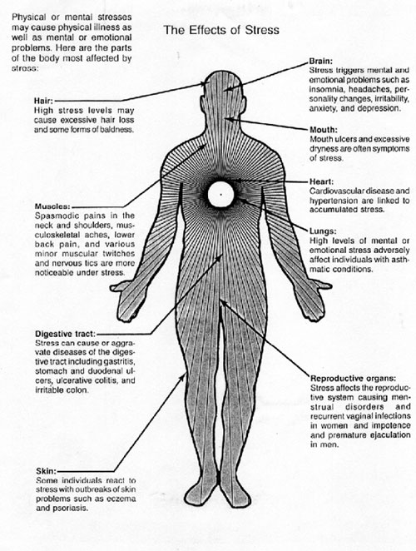
Symptoms: The most common and recognizable symptoms of stress are the ones most of us know all too well: insomnia, headaches, jaw pain, back and neck pain, stuttering, heartburn and nausea, nervousness and anxiety, fidgeting, nail-biting, lateness and trouble focusing, and a lack of interest in work or activities that are normally interesting. The American Institute of Stress (AIS) has a list of 50 common signs and symptoms of stress that include these, but also note a number of other symptoms that you may not have immediately associated with stress and not another condition like depression.
For example, behavioral changes that lead to other conditions can also be signs of stress, like addictive tendencies, a sudden interest in smoking, alcohol, excessive eating, or gambling, or any other addictive behavior that can be interpreted as an escape from chronic stressors. Often, even subconsciously, many of us try to escape stressful situations or conditions by blocking them out or escaping by way of anything that makes us feel better. Even if it's fleeting, it's common to search out an escape so you can relax for a while.Photo by The American Institute of Stress.
I spoke with Roger S. Gil, MAMFT, about some of the less productive ways people cope with stress, and he highlighted that trying to escape without dealing with the actual stressor is more common than you may think. "Overeating, alcohol/substance abuse, displaced anger, denial, defensiveness, etc. All are signs of avoidance and coping strategies that are meant to protect the ego from the discomfort caused by the stressor…and none of them do anything about the stressor," he explained. "Withdrawing (i.e. checking out mentally) from the situation at hand is something I see A LOT of in my work with couples. For example a husband may withdraw into his own little world when his wife complains about something. Instead of hearing her concerns, he pulls away and encourages her to nag him some more…which causes more withdrawal."
These behavioral changes cut both ways though: the AIS notes that stress reactions can also lead to isolation, loneliness, and severe depression as well. If you've been suddenly feeling alone, forgetful, overly defensive, disorganized, uninterested in your everyday life, overwhelmed by what's going on around you to the point where you need to lie about them, and having difficulty communicating with others, it's possible that chronic, poorly managed stress may be part of the problem.
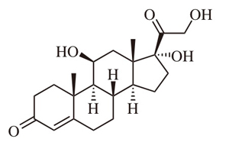
Physiological Effects of Stress: While stress is most often discussed in terms of how it changes our mental and emotional condition, stressors and stressful situations also have a profound impact on our bodies. Stressors, whether they're acute or chronic, immediately set off the body'sfight-or-flight response, flooding your system with stress hormones like norepinephrine andcortisol that are meant to give you a needed boost in dangerous situations. Image via Wikipedia.
In short and small bursts, those hormones can make you more alert, more perceptive, raise your heart rate so your muscles get more blood to them, and raise your breathing rate so you get more oxygen into your lungs. Your digestive processes stop entirely so your body doesn't waste energy processing food when it needs all the energy it can muster to survive. It's a good thing if, say, you're dashing across a busy street or escaping a burning building, but keeping your body's fight or flight response turned on all the time and those stress hormones at high levels in your body is unhealthy, as this eHealth article explains.
If these hormones stay in your system for too long, they can eventually lead to high blood pressure and increased heart rate, stress-induced hypertension and stroke risk, ulcers and other gastrointestinal distress, a suppressed immune system, fatigue, sexual issues like impotence and decreased libido. After all, those stress hormones are meant to be in our systems for a short period while we deal with an acute stressor, at a time where we need all of our faculties about us. Over the long term, keeping the body on full alert is more of a detriment than a benefit.

What You Can Do About Stress
Once you recognize the effects of stress and understand the damage you're doing to your body by not coming up with ways to cope with the stress that you're under, it's time to do something about it. I spoke with clinical psychologist Jeffrey DeGroat, PhD about some of the ways you can reduce the impact that chronic stress has on you and how to cope with acute stressors.
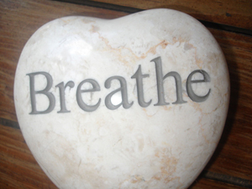
Dealing with Acute Stressors: If the stressor is acute and temporary, Dr. DeGroat suggests applying simple relaxation techniques like deep breathing, to calm the mind and the body so you can get the clarity you need to address the situation. He proposes taking a 10-second breathing cycle: breathe in for four seconds, and then out for six seconds. "Works as a thought distraction," he says, "as well as physically slowing down heart rate. This is a good technique to use anytime and anywhere." Photo by Shawn Rossi.
Previously mentioned app CalmDown for Mac is a utility designed just for situations like this: it encourages you to take a deep breath (or a few) so you can step back from the stressor for a moment, gather your thoughts, and push through the fog of frustration and anger that often come with stressors.

CalmDown for Mac Encourages You to Relax, Step Away From the Keyboard
Mac: If your computer or something you're dealing with on the web has you irritated, CalmDown…Read more
I also spoke with Roger Gil about dealing with stressful situations and he reinforced the point: "Stressors like these can produce physical responses at first; so if you're heart is racing, you're short of breath, or you feel your muscles tightening somewhere in your body, know that you're feeling a physiological stress response. In those cases, channeling your awareness of your body can sometimes distract a person away from the area of the body having the stress response." Recognizing that you're having a physical reaction will help you calm down and deal with the situation the way you really want to, as opposed to letting it stew in your mind only to come up with what you wanted to say 15 minutes after you should have said it.
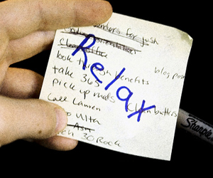
In that vein, Dr. DeGroat explains that figuring out what you wanted to say a few minutes after you said it is very common, and often a result of being unprepared for the stressful situation you're presented with. Aside from making sure to be ready for those situations in advance if you can be, he suggests acknowledging that you're stressed in the situation and telling the person or people you're dealing with that you'll get back to them later. Photo by Sasha Wolff.
"Rather than responding immediately with something we may regret later, or not saying anything at all," he says, "another option might be to indicate to the person that you'll talk to them later about the situation. For example, [imagine] you find out that a co-worker is dating an ex-boyfriend/girlfriend of yours. Rather than yelling at them and making yourself look out of control, or saying ‘oh, that's cool,' when you're really upset about it, you could say, ‘let's not get into this right now.' This will give you some time to collect your thoughts and approach them on your terms and on your time." Time, as Dr. DeGroat explains, is key to defusing acute stressors, letting your body and mind return to normal, and giving yourself the space to deal with them in a healthy way.
Dealing with Chronic Stressors: Stressors that you deal with on a daily basis or that are always hanging over your head are a different matter entirely. Usually they give you a little more time and space to deal with the thing that's making you stressed, and there are other relaxation techniques for stressors that may not require action on your part right away, or stressors that are always lurking in the background, like your boss, for example.
Visualization is one way to relax yourself when you're presented with a stressor that you don't need to respond to immediately. Dr. DeGroat suggests that if you can, take five to ten minutes to immerse yourself in the most relaxing environment you can possibly imagine, whether it's green fields, a chair by the sea, or your favorite easy chair at home. Focus on as much of that environment as possible, trying to manifest the sounds, smells, and details about it in your head. The more you do this, the farther away you'll get from the thing that's bothering you. It won't make that thing go away, but it will give you a little clarity of mind and distance from the stressor. Photo by Gabriel Pollard.
If you have additional time to relax and some space to be alone, Dr. DeGroat suggests progressive muscle relaxation to defuse some of the natural tension that comes with being stressed. "Systematically tense and relax muscle groups, beginning at your toes and working your way all to the top of your head. [This] serves as a distraction from current stressors and can help reduce physical tension that often accompanies stress."
Another tip Dr. DeGroat offers is to identify whether level of stress and your response to it is realistic or unrealistic when you're in the middle of it. If it's realistic, as in anyone would respond the same way and there's something you can do about it (like your computer froze or you just dropped something,) then address the situation and move on. If the response is unrealistic and others may not respond the same way (traffic isn't moving fast enough or security lines at the airport are too slow,) then address yourself: calm down, step back, and try to relax.
The first step to addressing yourself is to challenge the way you're thinking about the stressor. "Challenging these automatic thoughts that often hijack our minds and promote stress has been shown in research to be a great way to help break the patterns of thinking & behaving that are counterproductive/harmful," Roger Gil explained. "Once the 'mental battle' is won, the IRL battle is more easily handled."
Granted, none of these measures have to be practiced only in the context of chronic stress, but it is more likely that if your boss is getting on your nerves again today or the rent is due and you're worried about being able to afford groceries, you're more likely to take a few minutes and address how you feel so you can approach the issues in a clear manner than you are if you're stuck in a meeting and asked to speak on a topic you weren't ready for.
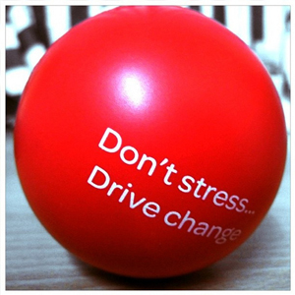

How to Deal with Stress In the Future
When I asked Dr. DeGroat how we could deal with certain kinds of stress that seem to crop up from time to time, like an overbearing extended family or an aggressive and disrespectful employer, he pointed out that while there are ways to deal with each situation on its own merits, much of the stress that gets to us the most comes from relationships. "Really, I believe stress in relationships (occupational, family, social), often includes difficulties with setting and maintaining boundaries. Others seem to expect too much from us. Rather than setting our own limits/boundaries, we allow others to cross these boundaries, and end up feeling irritated and resentful. One of the best ways to prevent stress in relationships is to identify our own limits/boundaries and hold to them," he says. Photo by Joel Mendoza.
In some cases, it may simply be better to remove yourself from chronic stressors if you're having difficulty adapting to them or minimizing them. After all, if your job is wearing you down and there's no improving it, it may be time to look for a new job. If your relationship is so stressful it's destructive for everyone in it, it may be time to break it off, and if your apartment is run down and your landlord won't fix it, it's time to move out. There are plenty of good reasons to learn to cope with stress, but there are other equally good reasons to remove the stress from your life when you can.
To that end, there's no real way to live a completely stress-free life. Remember, there are positive stressors as well as negative ones, and the positive ones are usually good experiences that we enjoy or seek out. The same applies for negative stressors: they're bound to happen eventually and avoiding them is a futile effort. The key is in knowing how to deal with them, and how to minimize their effect on you.
If the stress you're experiencing is chronic, consider other activities like taking up a hobby, meditating, or traveling—anything that can take your mind off of those stressors and provide a healthy outlet where you can relax. "Other helpful stressful coping mechanisms are exercise, doing an activity you're good at that won't worsen the stress (e.g. cooking, video games, etc), and watching a very engrossing movie/TV show," Gil said, "Sometimes interrupting the state of stress a person is in with an activity they enjoy is enough to keep them from losing control."
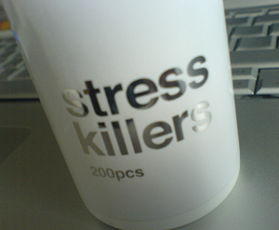
There's no magic formula for dealing with stress, but employing coping mechanisms that give you distance, helps you get through the moment, and at best minimizes the overall impact the stressor has on you are a good way to stay healthy, happy, and productive. Photo by Jacob Bøtter.
"It is how we approach it that can cause us problems, or allow us to grow. The more control we can find within a situation, or over ourselves, the more likely we will grow from the situation," Dr. DeGroat explained, "The more we are able to identify and act upon the control and choice we have in situations, the less debilitating the stress will be."

This is just a short introduction, but unsurprisingly, entire books have been written on the topic of stress, its medical and psychological implications, and how you can deal with it in healthy ways. While we hope we've given you some insight into how your body reacts to stressors and how you can manage them in the moment and on the long term, we know that this is by no means an exhaustive study into the topic. What are some of your most successful ways of dealing with stressful situations, both short and long-term? Share your suggestions in the comments.

