http://www.thenorthwestern.com/story/kidsincrisis/2017/03/31/kids-in-crisis-wisconsin-schools-movement-mental-health/98472280/

In classrooms, movement enhances mental health
Noell Dickmann and Jen Zettel , The NorthwesternPublished 10:42 a.m. CT March 31, 2017 | Updated 6:25 a.m. CT April 2, 2017
Pedaling towards improvement

Omro Elementary School administrators share how the use of DeskCycles, weights and more movement-minded equipment is transforming the school. March 30, 2017. Noell Dickmann / USA TODAY NETWORK-Wisconsin
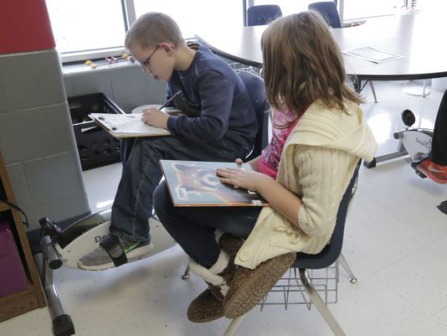
(Photo: Joe Sienkiewicz/USA TODAY NETWORK-Wisconsin)
OMRO - Olivia Juedes focuses intently on her fractions and mixed numbers homework. Below her desk, her feet silently push the pedals of a DeskCycle.
The small device's bicycle pedals stick out on either side of a center console with four rubber-ended feet holding it in place. It doesn't make a sound and Olivia, a fifth-grader at Omro Elementary School, said before she had it she used to tap her toes, sway her feet and fidget. With her feet moving, she gets more work done, stays focused and even racks up more steps on her fitness tracker. It's especially helpful for when she is reading.
The DeskCycle is just one tool she and her classmates can use in the classroom, which also has five- and eight-pound weights that 10-year-old Charlotte Stellphlug lifted a few feet away after she finished her class work.
"It helps me calm down and it helps my brain focus on one thing instead of thinking about everything," Charlotte said. She uses the weights once or twice a week.
A two-year study published in February 2016, which Omro school district administrators referred to as they brought the physical equipment into classrooms, found that elementary students who had physical activity incorporated into their lessons significantly improved in their math and spelling performance.
But staff in Omro said they were pleasantly surprised to see the benefits of the physical activity go beyond academics, as students' behaviors and mental health symptoms improved as well.
Dr. Eric Smiltneek, a family physician for ThedaCare in Oshkosh, said there is a clear link between exercise and mental health. He referenced a 2008 book by Harvard psychiatry professor John Ratey called "Spark: The Revolutionary New Science of Exercise and the Brain," which discusses how exercise activates the attention centers of the brain, especially in children.
The book states that the activation in the brain reduces cravings for new stimuli and increases alertness, Smiltneek said. Exercise also decreases learning helplessness, making it more likely that students will try a task they've previously failed to complete successfully. Data suggests that exercise does this by increasing the release of serotonin and dopamine; such neurotransmitters are common targets of antidepressant medications.
Smiltneek referred to Olympic swimmer Michael Phelps as a prime example of how exercise as medication can improve concentration. Phelps was diagnosed with attention deficit hyperactivity disorder when he was 9 years old. He stopped using medication at age 12 and changed to a behavioral-based approach, including swimming. The rest is history, Smiltneek said.
The physician, along with Oshkosh school board member Steve Eliasen , run Dr. Eric's Skate Club, a winter ice skating club for students, and International Youth Sailing of Oshkosh, a sailing club.
"The mental health benefits of exercise, especially outdoors, are part of the reason that I enjoy being active in sports like ice skating, skiing, sailing and paddle sports," Smiltneek said. "And why I advocate for students to get outside and be active."

Classroom cycles as learning tools
As Wisconsin students struggle with high rates of depression and mental health challenges, schools do not have enough staff to meet the need. USA TODAY NETWORK-Wisconsin first highlighted the shortage last year through the Kids in Crisis series.
Districts like Omro and Hortonville are finding creative ways to support mental health initiatives despite shrinking budgets.
Omro is a city of 3,500 people that lies 10 miles west of Oshkosh. About 1,300 students attend school in the district, and 620 students attend its two elementary schools. Staff at Omro Elementary School implemented the DeskCycles and weights into classrooms during the 2016-17 school year, an initiative led by the district's new pupil services director, Caleb Feidt. The devices caught on like wildfire at the elementary level, he said, and administrators plan to expand them to the middle and high schools.

RELATED KIDS IN CRISIS TOPICS
CHECK OUT THE SERIES: See all our Kids in Crisis coverage
VIDEO CONTEST: Submit a video a about mental health
E-NEWSLETTER SIGN UP: Get the latest Kids in Crisis stories in your inbox
WE WANT TO HEAR FROM YOU: Share your stories about youth mental health
Staff used the Omro School District's Value to the Cause grant program to fund the cycles, which are listed as $159 on Amazon.com. Teachers apply for Value to the Cause grants to fund grassroots initiatives that spark change in their classroom, building or community, or to improve specific learning and classroom initiatives. District administrators set aside as much as $20,000 a year to fund Value to the Cause.
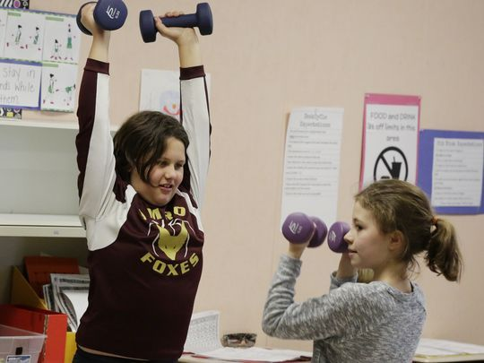
Chloe Derleth and Charlotte Stellpflug, fifth grade students at Omro Elementary School, lift weights during class. (Photo: Joe Sienkiewicz/USA TODAY NETWORK-Wisconsin)
Besides the weights and cycles, classrooms have inflatable sit discs — similar to an exercise ball — balance boards, wobble chairs and other tools to help fidgety or high-energy students get the energy out without distracting others. A separate resource room features all these tools and a treadmill, too.
The silent cycles come with a digital reader that will track a student's heart rate, speed and length of use. That helps staff track progress, along with the assessments and feedback from teachers and parents.
The goals are to teach children self-awareness, self-regulation and coping skills; to add more physical exercise into the day; to increase engagement with learning; and to reduce anxiety and stress, Feidt said.
Teachers introduced the devices as learning tools — not as toys — and students respect them as such. Any student who feels the need to use the tools can. Feidt said the staff wants to encourage students to figure out how they learn best and to use those strategies regularly.

A new way to think about schoolwork
It's making a huge difference, said Laura Wirth, a fourth-grade teacher.
Wirth said she had some particular challenges at the beginning of the year, including some very high-energy students and one in particular who had such a tough time with testing anxiety that he had to leave the classroom for every test.
Once she introduced the cycles and other tools, her students immediately embraced them, she said. The high-energy students now recognize when they need to burn some energy off. The child who struggled with testing anxiety uses the DeskCycle when he takes tests. He hasn't left the classroom to take one since. Students will recognize when a classmate needs the cycle more than they do and offer to share it.
It's a positive approach to addressing behaviors and issues in the classroom, compared to scolding students or other negative consequences, Wirth said.
"Sometimes you just need to get that little burst of energy out," she said.
Prevention is key, Feidt said. Staff hope that when the young students encounter stressors later in life, the strategies to cope with them will already be ingrained in their brains. That can improve students' mental health, as well as help all different kinds of students, including those with behavioral issues, mental health disorders or highly driven students who may just need a mental break.
"It's universal," said Jessica Koch, an Omro special education teacher who runs a resource room with a treadmill. "It helps anyone, differently."
If a tantrum arises, students take it out on the pedals or the treadmill, she said.
The equipment interweaves more activity in the day since students only get 25 minutes of recess, compared to the total hour of recess they had five years ago.
Kali Dubinski, fifth-grade teacher in Omro, said the tools help her students get through a six-hour stretch of morning lessons. Independent work time is more successful, too.
Before the desks, she spent independent work time managing behaviors, reminding students to stay on task and finding strategies for students to release their energy, such as quieting the sound of students' tapping pencils.
"Now we don't really have those habits anymore," she said. "They work quieter and engage themselves instead of distracting others. It creates a more silent, more efficient work area."
Her students stay on task more and have more options to engage the brain besides homework; they can move their feet on the cycles or take a five-minute break to lift weights. The amount of work they complete has also increased, she said, and she can see her students feel accomplished and proud because of it.
"I think that gives them a different way to think about schoolwork and their tasks," she said.

Strengths and screening
For some districts, physical programs are a way to focus on the whole child.
Three years ago, school leaders in Hortonville felt the district's Youth Risk Behavior Survey results about mental health were trending in the wrong direction, and they wanted to do something to turn things around, said Superintendent Heidi Schmidt.
After meeting with representatives from Outagamie County, Samaritan Counseling and Catalpa Health, officials realized there wasn't a comprehensive K-12 mental health initiative they could implement. Instead of giving up, the organizations and the school district worked together to create one.
That's how the E3 program was born.
It starts with education. The National Alliance on Mental Illness Fox Valley trained teachers on signs and symptoms of mental health issues. NAMI also provides resources for Hortonville parents.
Then comes the screening. Parents receive three notices that their children's screenings are coming up. They can opt their children out, but not many go that route, said Wendy Neyhard, director of student services.
Crystal Ludwig, the E3 screening site coordinator, reviews each questionnaire. Even though she runs Hortonville's school-based program, Ludwig is a Samaritan Counseling employee.
"Students take the questionnaire and that process identifies students who we want to do a follow-up screening with in-person," she said.
Based on what she finds in a follow-up interview, Ludwig will meet with students and their parents to figure out the best option for them. Most of the time, she connects them to resources in the community.
At the high school, E3 is supplemented by a student-led initiative called Sources of Strength. The worldwide program targets all students — not only those dealing with mental health issues.
The group at Hortonville High School runs campaigns to help students identify positive things in their lives — places and people they can turn to when they're struggling, said Sammy Holtz, a junior.
"It makes our school really unique," she said. "It's really changed the culture of our school, too. It brings us together as a family in high school. I've seen a reduction in bullying, a reduction in stigma. You hear positive conversation when you're walking in the hallway. It put out a vibe of positivity. That's all due to sources of strength."
During the E3 program's first year in Hortonville, nearly 800 high school students were screened. Of those, about 15 percent were referred to resources in the community, Neyhard said. So far this year, about 14 percent of students in grades 5-12 who took the questionnaire received referrals, Ludwig said.

A step toward better health
The successes at Omro are largely anecdotal, since the DeskCycles are still so new. However, there are early signs that point to that success growing.
Omro Elementary School Principal Dave Wellhoefer said there's been a 44 percent drop in referrals to his office this year. There were 94 referrals between September 2015 and March 2016, he said. As of March 14, 2017, there were 53 referrals. He attributes part of that decrease to launching a Positive Behavior Interventions and Supports program this year as well.
But the biggest key to their early success, he said, is the shift in school culture toward mindfulness, the growth mindset and interweaving the tools for their success into the natural learning environment.
Staff has buy-in, Wellhoefer said. Even he practices mindfulness; administrators are reading books on the topic this year and keeping their eyes on other school districts implementing similar concepts. Feidt and teachers pass articles back and forth on new research, and partner with chiropractors and physical education teachers to ensure they are teaching proper form.
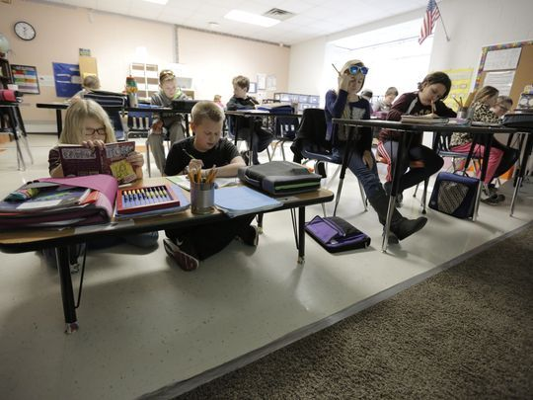
Paige Devorachek and Sebastian Maynard, both fifth-graders, use a short desk and a sit disc during class at Omro Elementary School. (Photo: Joe Sienkiewicz/USA TODAY NETWORK-Wisconsin)
It's just the tip of the iceberg, Wellhoefer said, sharing how a year ago he had no idea DeskCycles existed.
"We're willing to try anything and see if it has a good impact on kids," he said.
Noell Dickmann: 920-426-6658 or ndickmann@thenorthwestern.com; on Twitter @ONW_Noell; Jen Zettel: 920-996-7268, or jzettel@postcrescent.com; on Twitter @jenzettel

